1. Chart

   Description automatically generated with medium confidence
   1. string() failed cases.
      1. **Case 1: little extra space**:  
         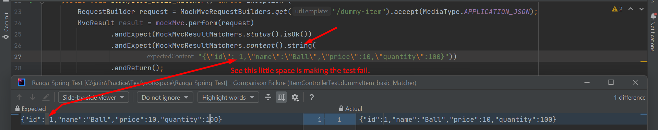
      2. **Case 2**: **Expecting has less fields than what we received**.  
         Graphical user interface, website

         Description automatically generated  
         **Solution**: **json**() instead of **string**()
2. Trying the same failed scenarios with json()
   1. **Case 1: little extra space**:  
      Graphical user interface

      Description automatically generated with medium confidence
   2. **Case 2**: **Expecting has less fields than what we received**